New England Skating Club Membership Form 2022-23
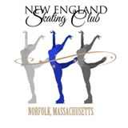

Acceptance of membership in the New England Skating Club subjects the member to all rules and regulations of the Club and requires that each member support the Club activities. The Club reserves the right to refuse or cancel any membership.
First Name: |  | Last Name: |  |  |  | Cell Phone:
Street Address: |  |  |  |  |  | Home/Other Phone:
City: |  |  |  |  |  | State: |  | ZIP:
Email: |  |  |  |  |  | USFSA No.:
Home Club: |  | New Home Club members please provide name of previous Home Club (if applicable):
Birth Date: |  |  |  |  | Gender - Circle One: |  | US Citizen?
Month: | Day: | Year: |  |  | Female Male |  | Yes No
Parent(s)/Guardian(s) Name(s):
Coach Name: |  |  |  |  | Coach Email:
Highest USFS Test Passed:
Free skating: |  |  |  | Moves In The Field:
Pairs: |  |  |  | Ice Dance:
PARENT VOLUNTEER AGREEMENT  The volunteer waiver fee of $100 has been added into the following membership options cost: Home Club, Family (first member only), and Introductory. |  |  |  |  | Volunteer Positions I am interested in (circle all)  Hospitality Banquet Committee Fundraising  Test Session Coordinator Ice Registration
For each hour of volunteer time, you will receive (1) freestyle ice credit to be used on NESC ice only. A total of (5) credits per season will be provided. |  |  |  |  | It is your responsibility to track volunteer time and submit to NESC within one week of completion on our website’s forms page.

Membership Categories and Fees: Please See Reverse Side
Membership Level: ____________________________
Membership Fee: $__________

Total: $__________

I hereby apply for membership in the NESC. For and in consideration of the acceptance by NESC Club of my application for membership, I hereby waive any right to claim damages against the Club, its officers, directors, and members, and release any and all of them from any liability, which may arise out of my membership therein. I have also read and understand the Bylaws of NESC. On July 1, 2013, U.S. Figure Skating implemented the Safe Sport program, which seeks to ensure that its members can participate in figure skating in a safe and harassment-free environment. As of January 1, 2022, this has been renamed to the SkateSafe Program. By joining NESC, I/we agree to adhere to the SkateSafe policies and NESC Bylaws. Detailed information on SkateSafe can be found on the USFS website. Applicants under the age of 18, must have a parent signature.

Member’s Signature (Or Parent/Guardian Signature if under 18 years old):_________________________________________________ Date: ______________

Please complete applicable information above and enclose payment for the appropriate membership fees. A form for each family member must be completed. Please make checks payable to NESC. Returned checks are subject to a $30 fee. Mail this membership application and fees to:
ATTN: NESC, MEMBERSHIP CHAIR
P.O Box 21 Norfolk, MA 02056
Questions? Contact NESC at: neskatingclub@gmail.com

New England Skating Club
Membership Categories 2023 - 2024

Every level of NESC FULL membership includes:
- Membership in NESC and a privilege to skate on Club Ice sessions, in exhibitions, special events and participate in any USFS Competition
- Participation in any Club social functions
- Subscription to SKATING Magazine (one per family)
- Coverage under USFS sports accident insurance policy

HOME CLUB MEMBERSHIP - $300.00 (Full)
Membership for individual skaters who test and/or compete at any and all USFS levels. Full membership voting rights. (Please note: $5 discount on Full membership when paying in cash or check.)

Includes volunteer waiver fee - maximum of (5) ice credits will be awarded for volunteering as outlined on first page.

FAMILY MEMBERSHIP Additional family members (Full)
$300.00 first family member, additional siblings $100.00 ea. (Please note: $5 discount on Full membership when paying in cash or check.)

Includes volunteer waiver fee - maximum of (5) ice credits per family will be awarded for volunteering as outlined on first page.

PROFESSIONAL MEMBERSHIP - $190.00 (Full)
Membership for coaches; requires USFS clearance and compliance. Full membership voting rights.

INTRODUCTORY MEMBERSHIP - $270.00
This full membership is open to first-time full members at a discounted rate. Introductory membership carries the same privileges as a full membership. ($5 discount when paying in cash or by check.)

Includes volunteer waiver fee - maximum of (5) ice credits will be awarded for volunteering as outlined on first page.

PARENT/GUARDIAN MEMBERSHIP - $90.00 each (Full)
Membership for parent(s)/guardian(s) of a Home Club or Second Club member skater. Parent/guardian can be a skater or a non-skater. Includes full membership voting rights. Ideal for either a parent/guardian & child member whom both skate, or for parent(s)/guardian(s) of a member skater who wish to be members to support our Club and US Figure Skating.

COLLEGIATE MEMBERSHIP - $200 one time fee covers 4 years

BASIC SKILLS MEMBERSHIP - $75 each
Does not include voting rights. Applies only to basic skills activities/tests.

NON NESC HOME CLUB MEMBERSHIP OPTIONS:

ASSOCIATE CLUB MEMBERSHIP - $120.00
*Membership for individual skaters who test and/or compete at any and all USFS levels and belong to a home club other than NESC. Includes club privileges other than home club status.

ASSOCIATE PROFESSIONAL MEMBERSHIP - $80.00
* Full membership is held at another club

*Does not include additional SKATING Magazine subscription. Your subscription is included in membership with your home club.

Please make all checks payable to New England Skating Club.
NESC is a Non-Profit Corporation pursuant to Internal Revenue Service Code Section 501(c)(3) and M.G.L. Chapter 180.
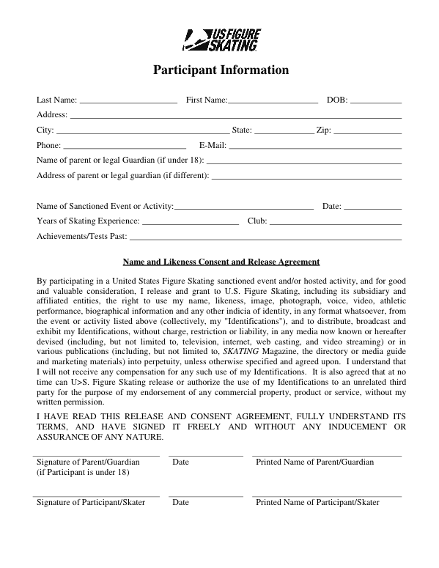

^{New England Skating Club}
Waiver and Release of Liability, Assumption of Risk and Indemnity Agreement (“Agreement”)
In consideration of participating in activities, I represent that I understand the nature of figure skating activities (“activity”) and that I am qualified, in good health and in proper physical condition to participate in such “activity”. I acknowledge that if I believe event conditions are unsafe, I will immediately discontinue participation in the “activity”.
I fully understand that this “activity” involves risks of serious bodily injury, including permanent disability, paralysis and death, which may be caused by my own actions, or inactions, those of others participating in the “activity”, the conditions in which the “activity” takes place, or the negligence of the “releasees” named below; and that there may be other risks either not known to me or not readily foreseeable at this time; and I fully accept and assume all such risks and all responsibility for losses, costs, and damages I incur as a result of my participation in the “activity”.
I hereby release, discharge, and covenant not to sue the , United States Figure Skating, it’s directors, officers, administrators, sponsors, volunteers, agents, employees, staff, instructors, trainers, other participants and if applicable, owners and lessors of premises on which the “activity” takes place (each considered one of the “Releasees” herein) from all liability, claims, demands, losses, or damages on my account caused or alleged to be caused in whole or in part by the negligence of the “releasees” or otherwise, including negligent rescue operations; and I further agree that if, despite this release, waiver of liability, and assumption of risk, I, or anyone on my behalf, makes a claim against any of the Releasees, I will indemnify, save, and hold harmless each of the releasees from any loss, liability, damage, or cost which any may incur as the result of such claim.
The has the right, but not the obligation, to provide rules, regulations and/or ice monitors for Club Ice. We hereby acknowledge that the shall not be responsible for the supervision of the members at Club Ice.
I have read this RELEASE AND WAIVER OF LIABILITY, ASSUMPTION OF RISK, AND INDEMNITY AGREEMENT, understand that I have given up substantial rights by signing it and have signed it freely and without any inducement or assurance of any nature and intend it to be a complete and unconditional release of all liability to the greatest extent allowed by law and agree that if any portion of this agreement is held to be invalid, the balance, notwithstanding, shall continue in full force and effect.

___________________________________________ ______________________________
^{Printed Name of Participant} ^{Date}

__________________________________________________________________
^{Signature of Participant}

PARENTAL CONSENT AND INDEMNIFICATION AGREEMENT
I, the minor’s parent and/or legal guardian, understand the nature of the above referenced activities and the minor’s experience and capabilities and believe the minor to be qualified to participate in such “activity”. I hereby release, discharge, covenant not to sue and AGREE TO INDEMNIFY AND SAVE AND HOLD HARMLESS each of the Releasees from all liability, claims, demands, losses, or damages on the minor’s account caused or alleged to have been caused in whole or in part by the negligence of the Releasees or otherwise, including negligent rescue operations, and further agree that if, despite this release, I, the minor, or anyone on the minor’s behalf makes a claims against any of the above Releasees, I WILL INDEMNIFY, SAVE AND HOLD HARMLESS each of the Releasees from any litigation expenses, attorney fees, loss liability, damage, or cost any Releasees may incur as the result of any such claim.
________________________________________
Printed Name of Parent/Guardian

________________________________ Date_______________________________
Signature of Parent/Guardian

Consent for Medical Attention or Treatment
I certify that I, the member, or I, the parent/guardian of said participant, give my consent to the
and the facility the activities are taking place in and their staff and to members of the New England Skating Club, their Board of Directors and volunteers to obtain medical care from any licensed physician, hospital or clinic, including transportation and emergency medical services, for myself/ourselves and/or said participant for any injury that could arise from participation in these activities.

________________________________ _______________________________________
Name of 1st Minor Child Member (please print) Name of 2nd Minor Child Member (please print)

Name(s) of Parent(s)/Guardian(s):
1st Parent/Guardian Signature: ___________________________ Date: __________________

2nd Parent/Guardian Signature: __________________________ Date: __________________

Name of 1st Adult Member:______________________________
^{(please print)}
1st Adult Member Signature:_____________________________ Date: __________________

Name of 2nd Adult Member: _____________________________
^{(please print)}
2nd Adult Member Signature: ____________________________ Date: __________________

This Consent for Medical Attention shall be binding and effective for the 2022-2023 membership year.

FREQUENTLY ASKED QUESTIONS:
What is US Figure Skating? US Figure Skating is the official governing body for the sport of figure skating in the United States, recognized by both the United States Olympic Committee (USOC) and the International Skating Union (ISU). As the governing body, US Figure Skating's mission is to provide programs to encourage participation and achievement in the sport of figure skating. As the governing body it regulates and governs the sport in the United States, creates rules for the holding of tests, competitions and other activities, and organizes and sponsors competitions.
What are the benefits to joining US Figure Skating? By joining U.S. Figure Skating through a club, such as NESC, members have the ability to do the following: 1) Test at U.S. Figure Skating-sponsored test sessions 2) Compete at U.S. Figure Skating-sanctioned events 3) Participate in U.S. Figure Skating qualifying events 4) Represent your club at regional, sectional and national events. Members also receive the following benefits: 1) Certificates of accomplishment for passing proficiency tests and placing at U.S. Figure Skating qualifying events (athletes) 2) Subscription to SKATING magazine 3) Individually numbered membership card 4) Coverage under U.S. Figure Skating's sports accident insurance policy and 5) Special offers and discounts from U.S. Figure Skating corporate partners.
Why should I join the New England Skating Club? US Figure Skating is made up of local clubs, of which there are several in the Boston area alone. When you apply to be a NESC "home club" member, we will submit your information to the national organization, and you will receive a membership card and number from US Figure Skating headquarters in Colorado showing that you registered through NESC. Your US Figure Skating number is used to track your participation in US Figure Skating sanctioned testing and competitions, no matter what club you belong to in the future.
What does "home club" membership signify, versus being an associate member? Your "home club" is the club which registered you with US Figure Skating. You may join other clubs as an "associate" member. If club sponsored events, such as test sessions, are over-subscribed, home club members would have higher priority. You must be a NESC club member (home or associate) if you wish to purchase an ice contract or coupon books for skating sessions sponsored by the NESC.
When does my membership expire? All US Figure Skating and New England Skating Club memberships renew on July 1st.
How do I get a permission letter to participate in a competition, test session or ice show sponsored by another club? Permission letters can be requested from any club officer. You or your coach should contact the applicable test chair (singles/pairs or dance) to inquire if a test permission letter is needed.
How do I purchase club clothing? Our figure skating boutique at the Norfolk Arena is a full service shop. Offering everything a figure skater needs from tights, costumes to club jackets skates and more!
Where can I find the Club Bylaws? Our Club Bylaws can be found on our website here: www.newenglandskatingclub.net/board-of-directors

If you have any questions, please do not hesitate to contact a member of the board via email: neskatingclub@gmail.com

